الجمهورية اللبنانية
وزارة التربية والتعليم العالي الامتحانات الرسمية لشهادة الامتياز الفني
المديرية العامة للتعليم المهني والتقني لدورة عام 2011 الثانية
===============
الاختصاص والرمز : المعلوماتية الادارية (24004) –الانظمة والشبكات (24101)
المادة : التطوير التطبيقي بالانترنت – البرمجة بلغة انترنت المعدل: (8-6)
المستندات المسموح بها : لا شيء المدة : ساعة ونصف

N.B: All the "HTML" files are in the folder: \exam\html\
All the "AUDIO" and "VIDEO" files are in the folder: \exams\multimedia\
All the "IMAGES" files are in the folder: exam\images
All others files are in the folder: \exam\others\

I- Write the appropriate tags to obtain as a result the following page « page1.html » respecting the following conditions:  (7 pts)  - The page author is « webmaster ».  - The keywords used by search engines are: "marriage, Honey moon".  - This page will be redirected to the address www.google.com after 45 seconds of displaying this page.  - Background color of this page is blue.  - The title has the biggest possible size, the color is red and the font is ‘Times New Roman’.  - The image name is « pic1 ». This image is animated and it’s up to you to choose the extension. The border width of this image is 3 pixels.  - The Music « music1.wav » is infinitely launched when this page is opened.  - The link « Contact US » sends an email to the address: ‘contact@wed_plan.com’.  - The link « Home » re-displays this page. | 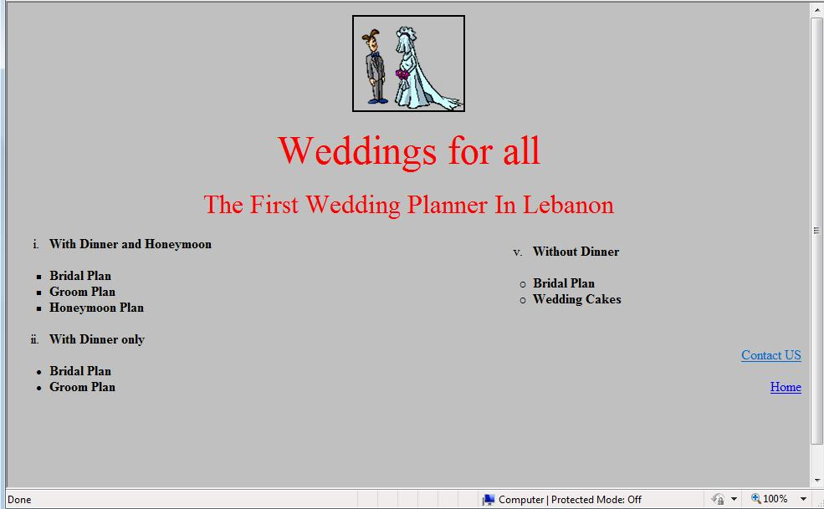
II- Write the appropriate tags to obtain as a result the following page « page2.html » respecting the following conditions :  (4 pts)  - Page title is « Articles »  - The color of the non visited links is green.  - Images names are respectively pic2.jpg and pic3.jpg.  - This page has as a background the image pic4.bmp.  - The table border color is green. The thickness is of 2 pixels.  - The distance between the text and the border sis 2 pixels.  - The link « Download Catalogue » downloads the file « catalogue.pdf »  - The link « Home » opens the page « page1.html » | 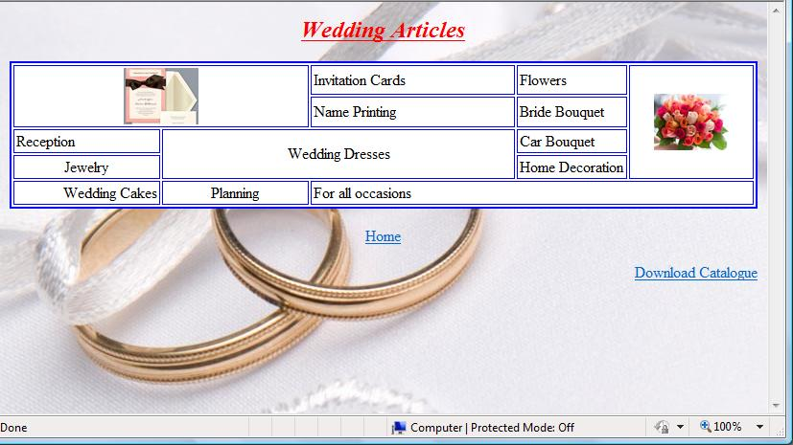

الاختصاص والرمز : المعلوماتية الادارية (24004) –الانظمة والشبكات (24101)
المادة : التطوير التطبيقي بالانترنت – البرمجة بلغة انترنت المعدل: (8-6)
المستندات المسموح بها : لا شيء المدة : ساعة ونصف

 | III- Write the appropriate tags to obtain as a result the following page « page3.html » respecting the following conditions:  (4 pts)  - First Name: Entry Field of 50 characters .  - Last Name: Entry Field of 50 characters  - Address: Entry field of 50 characters and 3 lines.  - « Bride » and « groom » only one of these values can be chosen.  - « Lebanese » and « Other » only one of these values can be chosen.  - « Plans » contains the following values: « With Dinner and Honeymoon », « With Dinner Only » and « Without Dinner ». You can choose all of them at the same time. By default all the three of them are selected.  - « Number of people invited » contains the three values : « 50 », « 100 » and « 200 »  - The button « Submit » sends the data to the server www.wed_plan.com using the Perl script « send.pl »  - The button « Reset » restores the original values by default. | 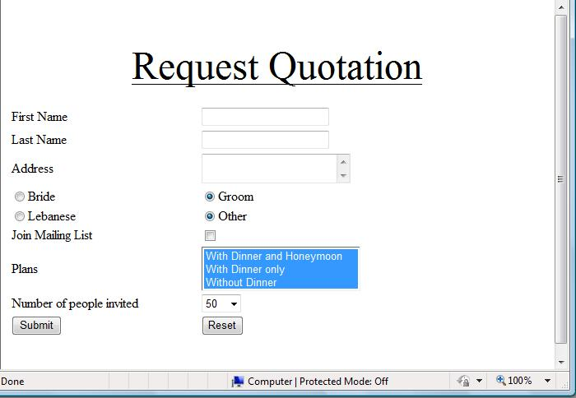

Frame B:
Height : 100 %
Width: 20%
Frame A:
Height 10 %
Width:80%
V- Write the appropriate tags to obtain as a result the following page « index.html» respecting the following conditions:  (5 pts)  - This page is composed of three frames A, B and C.  - The first frame "A" holds only the phrase « Contact Us as soon as possible ». This phrase is a scrolling message from right to left 10 times.  - The frame B contains the links « Home », « Dinner and Honeymoon» and « Inquiry ». These links display respectively the page « page1.html » in frame C, the page « page2.html » in frame C and the page « page3.html » in a new page.  - The third frame C displays by default the page « page1.html »  - Create all needed and not exiting pages, and add all needed tags to the existing pages. | 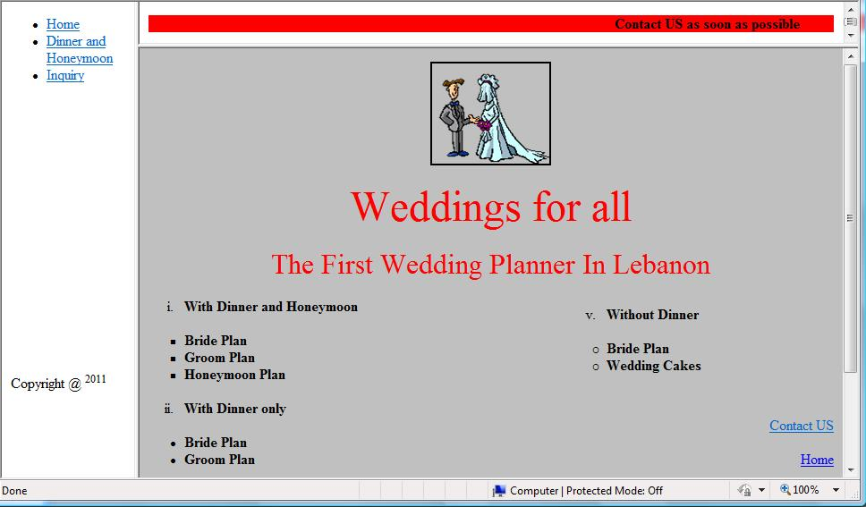  Cadre C:  largeur 85 %  hauteur:70%
Frame C:
Height: 90%
Width:80 %

